**ONLINE HOTEL RESERVATION PROJECT**

**CS 631 – Database Management System Design**

**Katie Perkins**

**Sudhan Rameshwaran**

**Yusuf Sabuwala**

**Project Overview**

In this project we are designing and implementing Database for an Online Hotel Reservation application. The project is about a fictional Hotel chain – Hulton which has many hotels all over the world. The database built for the Online reservation system is for storing data about their hotels, rooms, services/breakfast offered in each hotel, Customer, reservation transaction and Customer reviews.

**Phase 1 Goals:**

* Analysis of Intended DB System and create Conceptual Schema using ER/Extended ER Diagram
* Provide Assumptions made during Schema Design
* Mention Challenges/Problem faced
* Our ER diagram will capture various entities, along with their attributes and relationship types. This will provide a clear understanding of the data structure.

**ER/Extended ER Diagram:**

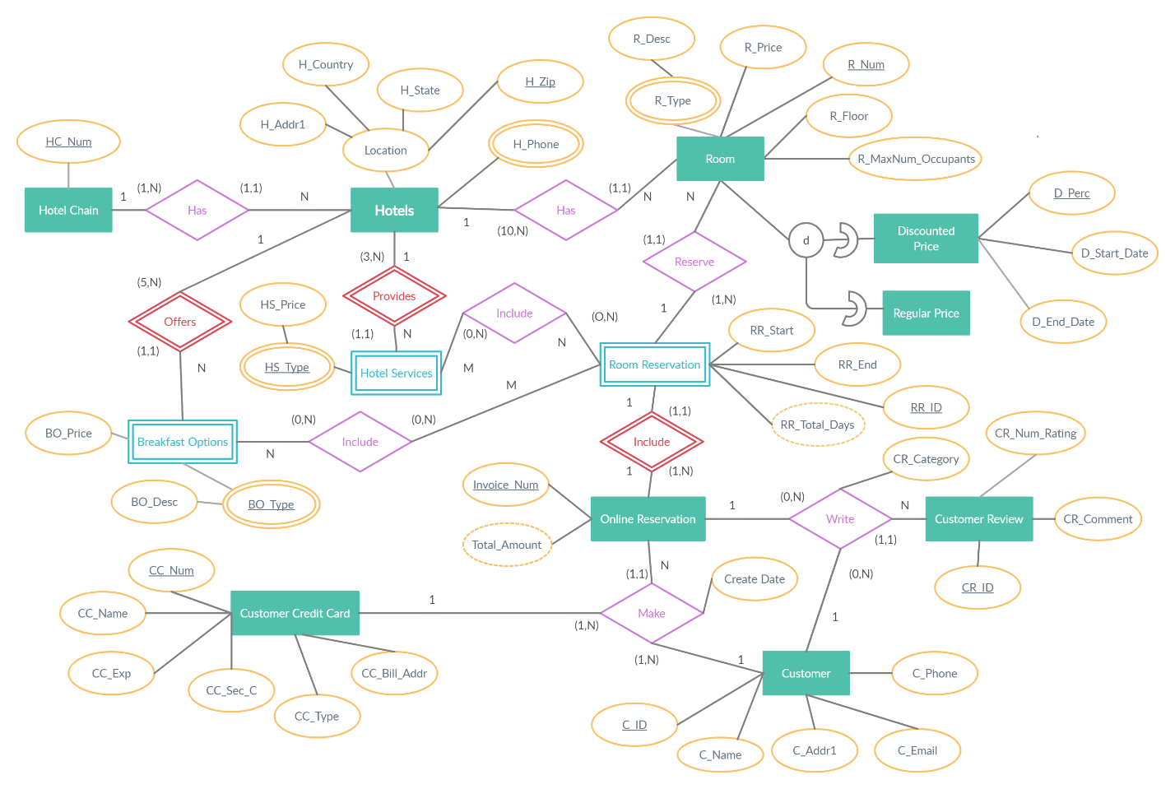

**Assumptions:**

* Hotel Chain was not added as a separate entity as a Super Class as there were no attributes provided. The hotel number is assumed to be attribute of Hotel Entity.
* Room Types – Standard, Double, Deluxe, Suite are not mentioned as separate Entities of type “Room” as they were only specified as examples.
* A regular price entity is needed as a subclass of Room

**Challenges:**

* We had challenges in representing the ternary relationship between Customer, Credit card and Online Reservation
* It was challenging to decide if Room should be a weak or strong entity. If a Room Number could be 100 in Hotel A and 100 in Hotel B, this would mean the Hotel is needed to identify a Room making it a weak entity.
* The structural constraints are difficult to decide on at this stage.